**Solution Quick Start: Elastic Pool Telemetry using PowerShell**

Below are instructions on how to execute the PoolTelemetryJobRunner.ps1 script:

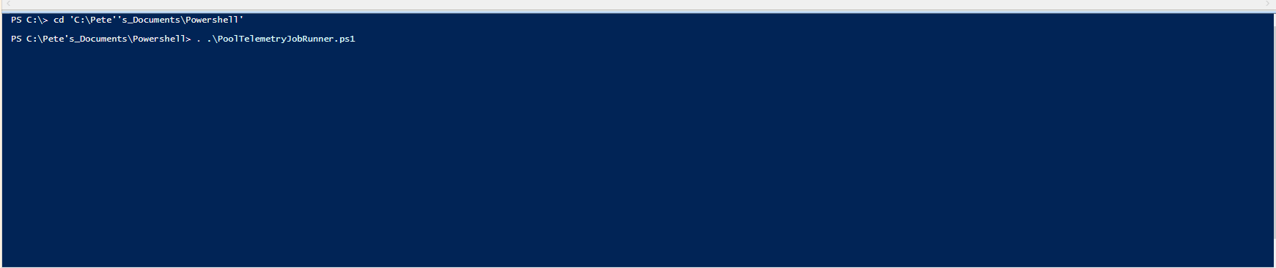

Next you will be prompt to enter your username and password

